**EE402 Report for Closed Loop Performance**

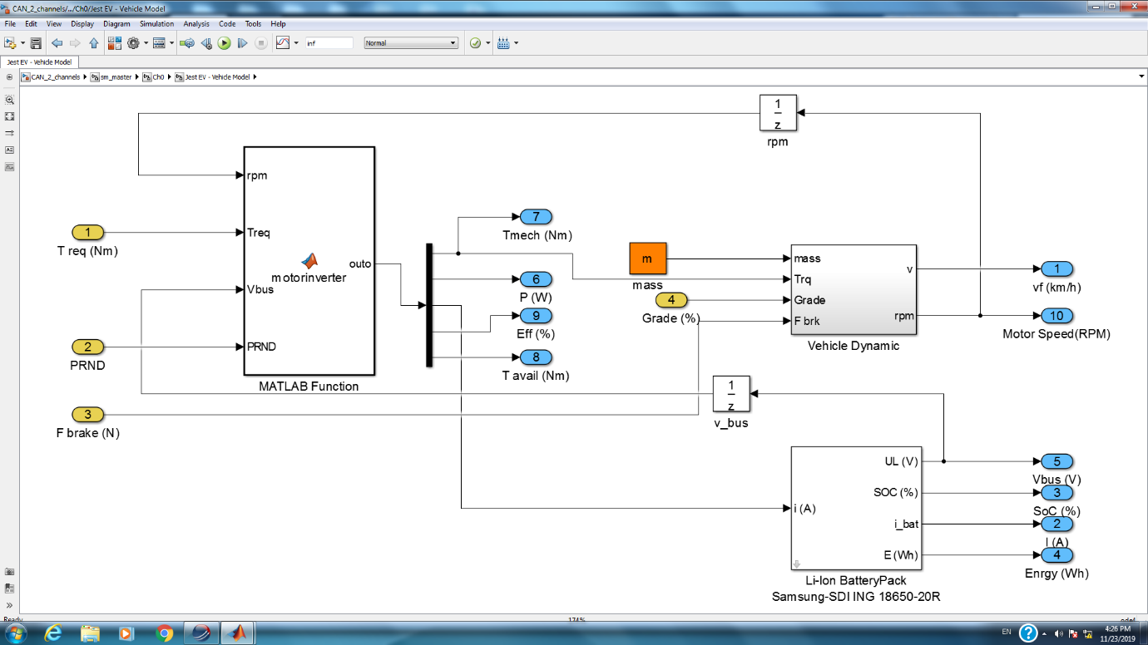Besides the battery, motor and inverter are the most important parts of an electric vehicle. The inverter block receives a torque request from the driver and generates a suitable amount of current to drive the electric motor so that the vehicle accelerates as required. Here is a depiction of the EV model.

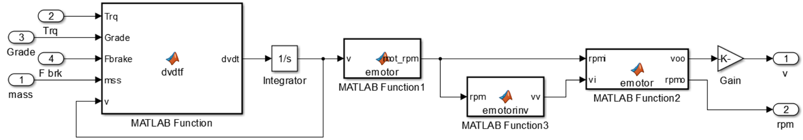**Figure 24: EV Model**

**Figure 25: EV Model - Vehicle Dynamics Block**

The Simulink model that consists of these blocks has a sample time of 0.001s. But the vehicle model execution rate is at 0.01s meaning that number of steps without overruns for this model must be 10.

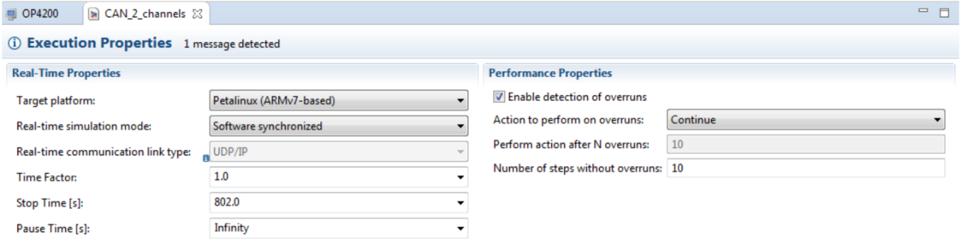

**Figure 26: HIL Model Execution Properties**

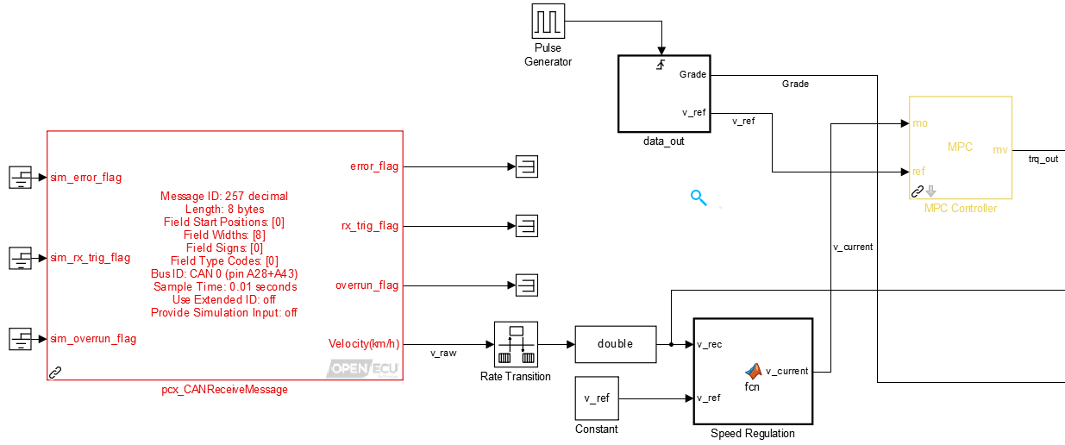**Figure 27: Control Algorithm - Part1**

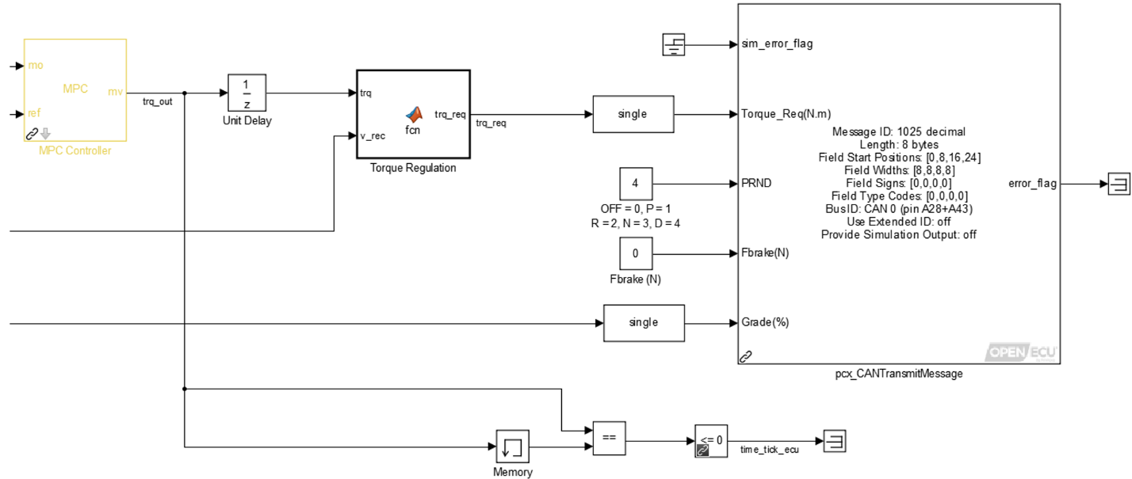Having our vehicle speed updated every 0.01 seconds allows the HIL side to behave more like a real plant. Also, it means that our ECU should receive messages from CAN bus every 0.01s. But since our controller’s sample time is 0.1s, desynchronization might occur. To allow, fast-to-slow transmission in the model, a rate transition block is added. This block acts as a zero-order hold to adjust data transmission rate and ensures data integrity during its transfer. It basically holds the data back from being transferred until the ECU time tick is reached. Later, a speed regulation function is added to prevent any mismatches. Due to reference speed data and grade data having 1s periods, a pulse generator with a 1s period and a 10% pulse width is added to trigger the block at the right rate to provide reference speed and grade data input.

**Figure 28: Control Algorithm - Part2**

After the MPC block, the torque output is regulated as well with a function block. Finally, the ECU time tick is calculated, and the data is transmitted via the CAN bus.